JANTA VIDYA MANDIR GANPATRAI RASIWASIA COLLEGE, CHARKHI DADRI
Faculty Profile

Department GEOGRAPHY

Name of Faculty |  | PARVIN KUMAR |  |  | 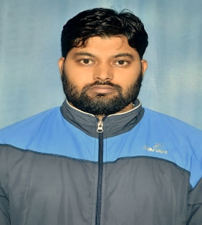
Department |  | GEOGRAPHY
Designation |  | ASSISTANT PROFESSOR
Experience |  | 6 years
Contact No |  | 90504179997
Email Id |  | PARVINKHATOR88@GMAIL.COM
Date of Joining |  | 16/11/2021
Educational Qualification
 | Name of Program |  | Year of  Passing | University
PG | GEOGRAPHY |  | 2016 | KUK
Ph.D.
Net | GEOGRAPHY |  | 2017 | UGC
Other
Research Supervision/Guidance |  | NO
Research Publications |  | NO
Books Published |  | NO
Book Chapters |  | NO
Papers Presented in Conferences/ Seminar |  | International 2 National: -
Participated in Conferences/ Seminar |  | International: - National: 4
No. of Workshops/FDP/Training Programme Attended |  | NO
Major/Minor Research Projects |  | NO
Invited Lectures
Awards/Honours
Membership of Any  Professional/ Statutory Body |  | NO
Any Other Achievement |  | M..SC MASS COMMUNICATION (GJU HISAR)

